How to get the field name for the fields on the screen:

1. Go to Tcode MM01( used to create a material)

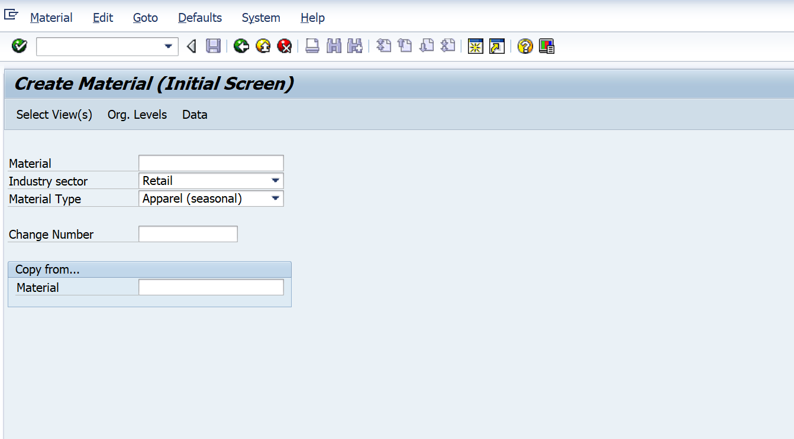

1. Click on any field out of the 3 (material, industry sector and material type) and Press F1.

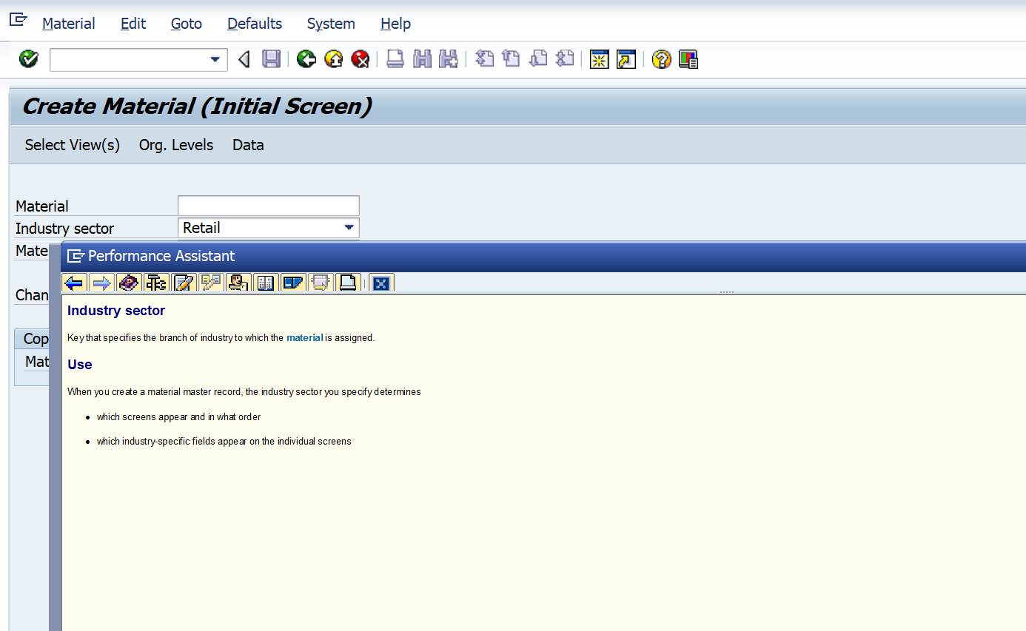

1. Select the tools section/technical information on the tool bar

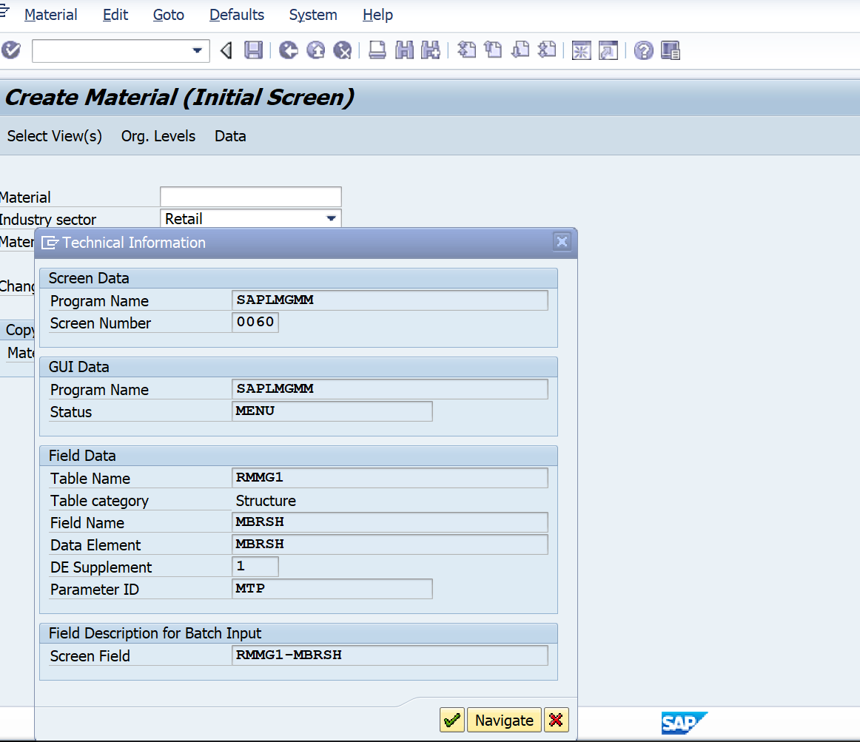

1. Click on Data Element

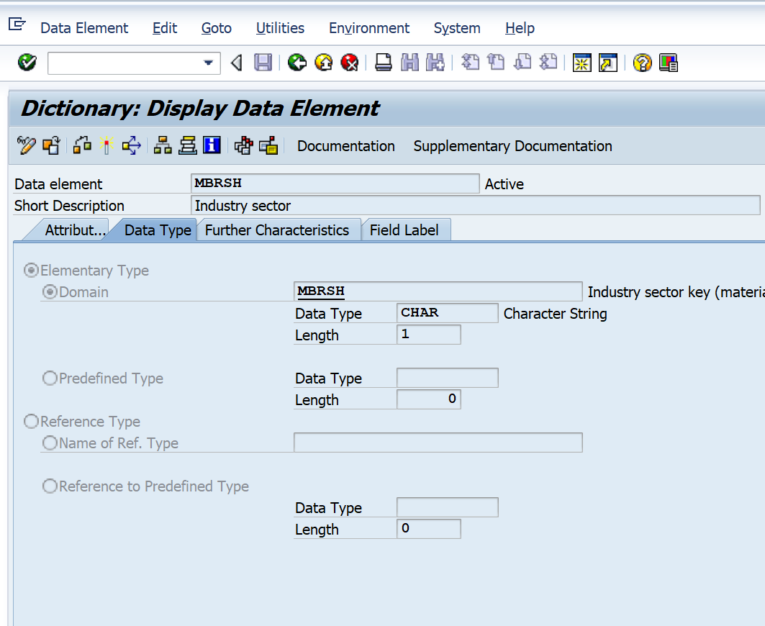

Go in the domain

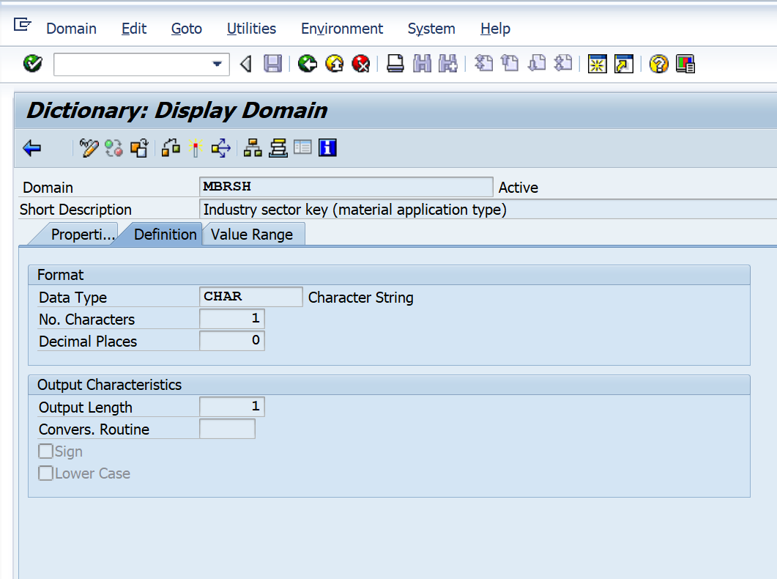

Go to value range

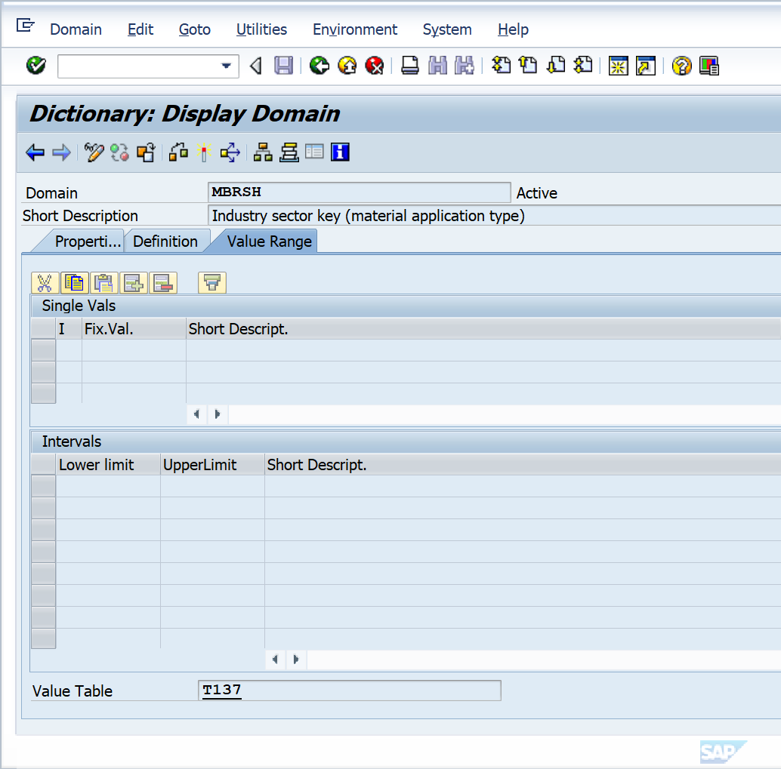

Go to the value table and check the contents

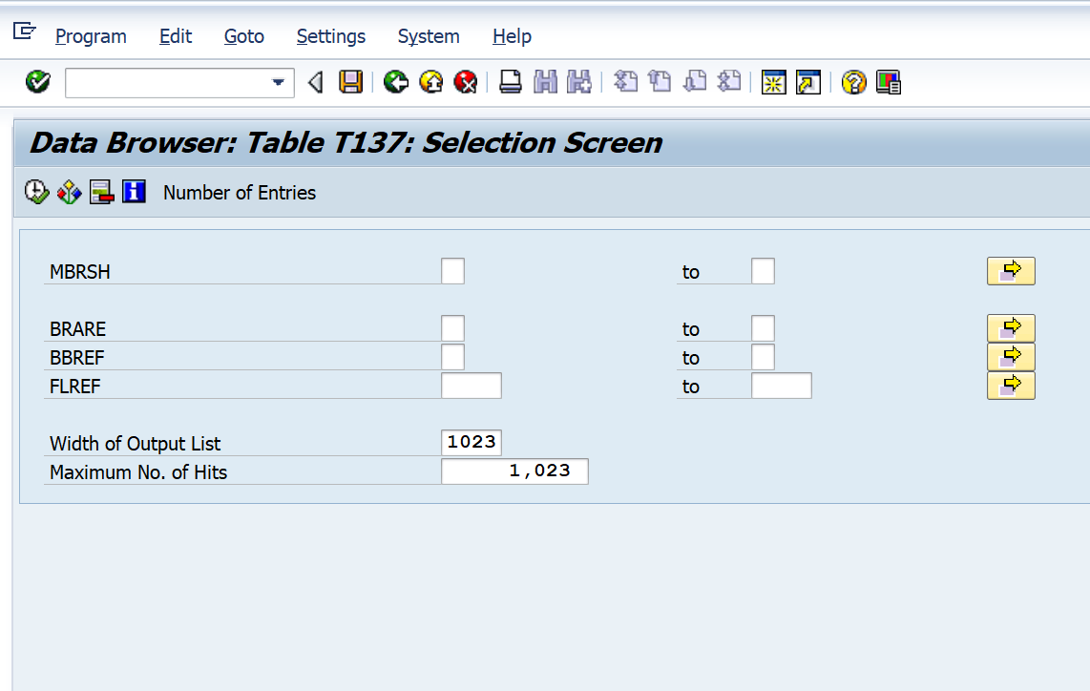

Press F4 on any field to get the acceptable values for tht field.

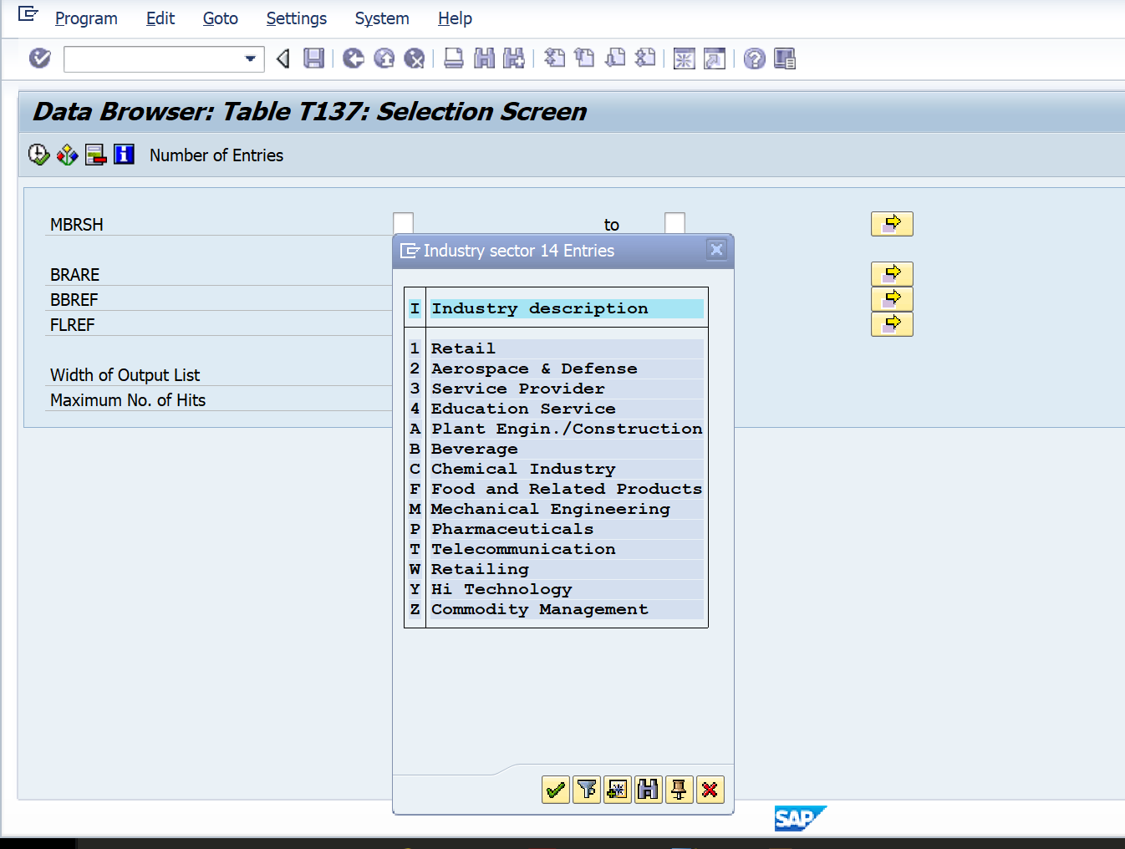

So, in the recording when we select say Retail, it will get saved as 1 and for Beverage it will be saved as B.